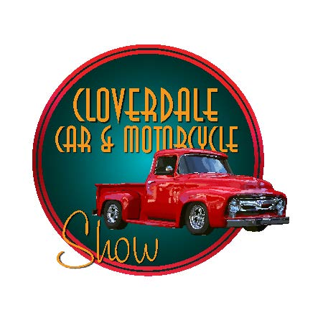

Saturday, Sept.7, 2024 10am– 3:00pm

$100.00
Sponsor an Award Trophy. Recognition at the awards presentation. Sponsor will be in-charge of selecting winner of the Trophy and placing it in their vehicle by 2pm. Trophy will have business name on it.

*If you want to sponsor a trophy, you must submit a form by July 30th
$500
Friends of the Cloverdale Car Show. Recognition at the awards presentation. Sponsor recognition in Cloverdale Connect/ Social Media, the Chamber Car Show Website and Newsletter. Invitation to after car show event.

Cloverdale Chamber of Commerce, 126 N. Cloverdale Blvd, Cloverdale, CA 95425. Email us at: info@cloverdalechamber.com
Visit us at: www.cloverdalecarshow.com 707-894-4470

NAME _ PHONE _

ADDRESS CITY ZIP
WEBSITE EMAIL

LEVEL OF SPONSORSHIP:

